**Super Mall Web Application**

Project Title

Super Mall Web Application - Manage Shop’s Offer,

Products & Location

Technologies

HTML, CSS, JS, and Firebase

Domain

Industry

Project Difficulties level Hard

Problem Statement:

A Super Mall Web app is a website that allows merchants to advertise and sell their products at developing counters. Rural towns would be able to sell their commodities to the rest of the globe as a result of this.

The goal of this project is to establish a portal that allows consumers to securely update product information using a mobile device while also allowing them to purchase goods from the merchant. The user's primary concern is to discover their talents and to improve our commercial business's ability to reach out to customers.

In the future, the internet will become the heart and soul of the business world; all trades will be conducted through it, therefore this gateway may be beneficial to the user as a business.

System Modules:

Admin Panel (Admin Login)

|  |  |
| --- | --- |
| **Username** | **Password** |
| Admin | Admin |

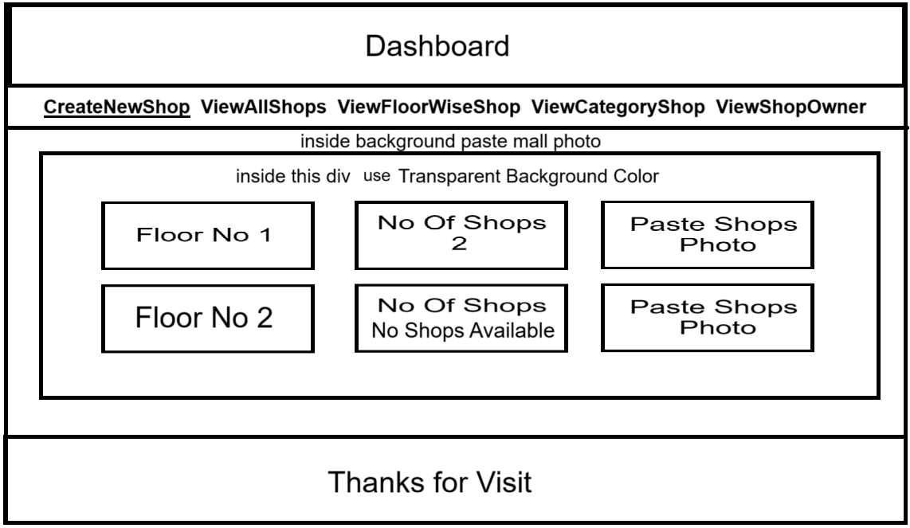 **Admin Panel** Front Page View



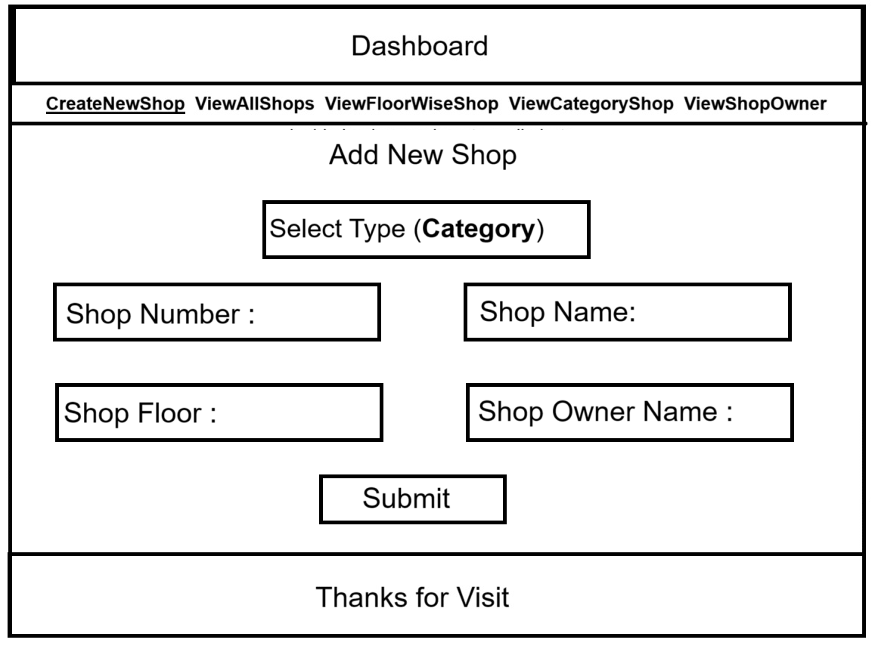 Create Shop Details (Module Name **Create_Shop** )



|  |  |  |  |  |  |
| --- | --- | --- | --- | --- | --- |
| Id | Shop Number | Shop Name | Shop Floor | Shop Owner Name | Shop Type (Category) |
| jcsfete2asa3da | 1 | Pawar Multi Services | 1 | Kiran Pawar | Technology |
| jcsfete2asa3da | 2 | Raj Automobiles | 1 | Raju Shinde | Hardware |
| jcsfete2asa3da | 3 | Sham Tours And Travels | 1 | Sham Ekhande | Tours And Travels |

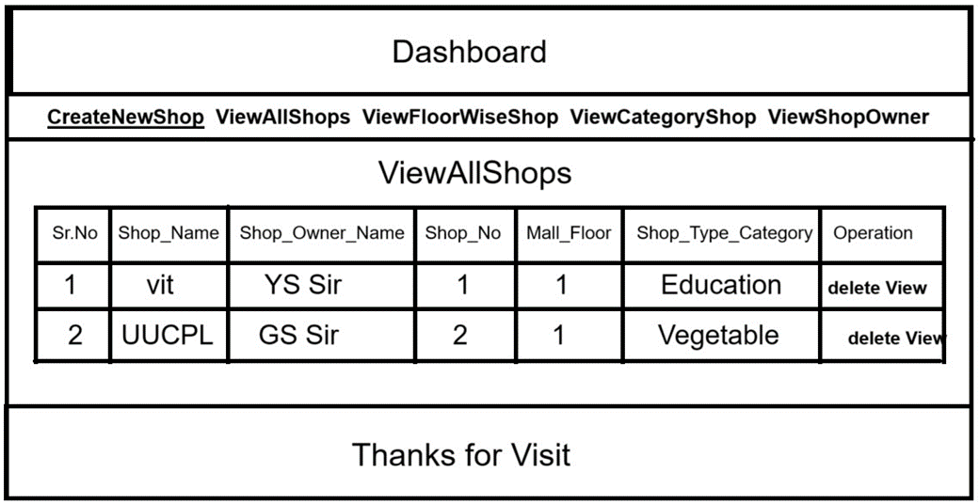 Manage Shop Details? module name ( **View_All_Shops** )



|  |  |  |  |  |  |  |
| --- | --- | --- | --- | --- | --- | --- |
| **Sr.NO** | **Shop Name** | **Shop Owner Name** | **Shop No** | **Mall Floor** | **Shop Type**  **(Category)** | **Operation** |
| 1 | Pawar multi Services | Kiran Pawar | 1 | 1 | Technology | Delete **Views** |

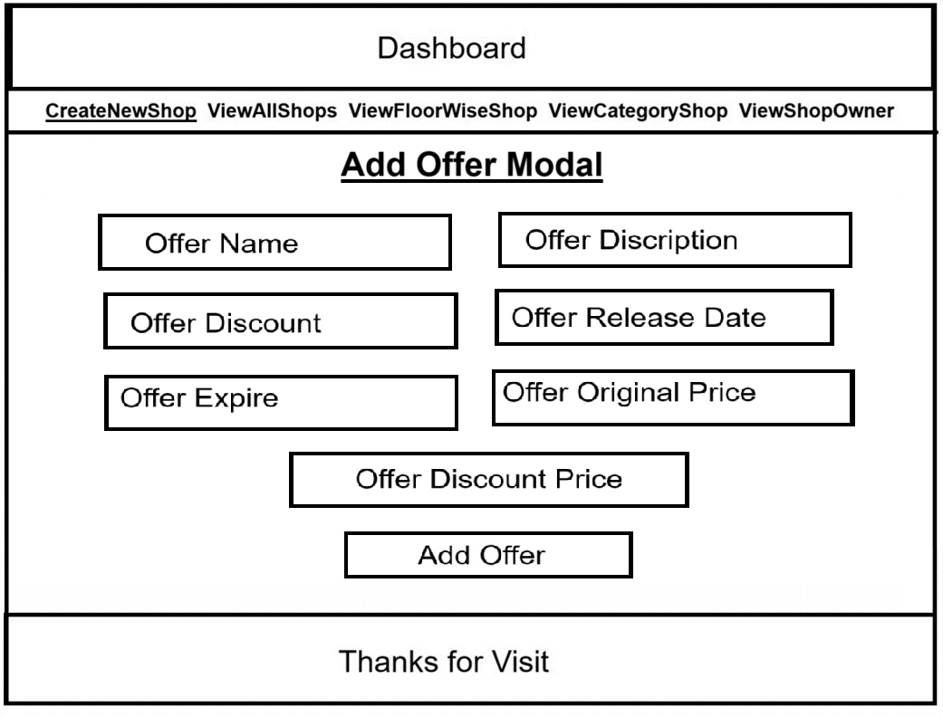**If you click on View Button View SingleShopDetails in this page you create (Add_Offer_Model) this module is used for Add Offers like !!Diwali Festival**

**Dashera Festival and many more.!!**

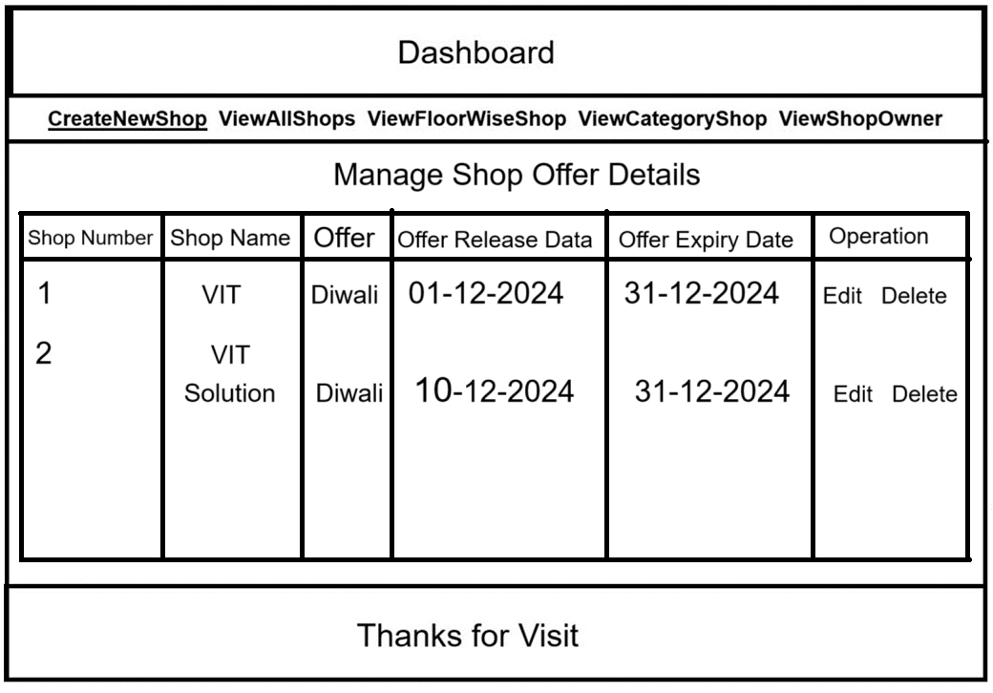 Manage Offer details? Module Name (**ViewOffers**)



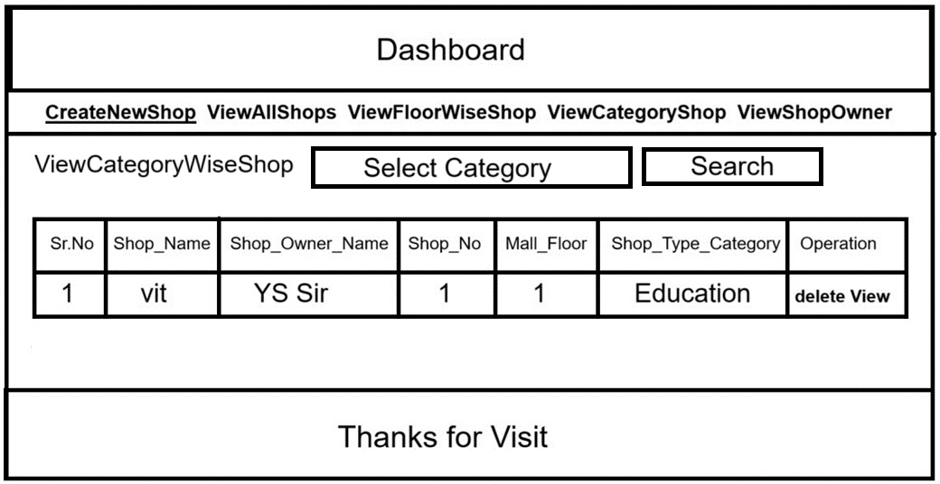 Manage Category & Floor? ModuleName (**ViewCategoryWiseShop**)



User

 Category Wise Details  List of shop Details

 List offer Products

 Compare Products cost & Features  Filter

 Shop Wise Offers  Floor Wise Details  View Shop Details

Project Evaluation metrics:

Code:

 You are supposed to write a code in a modular fashion  Safe: It can be used without causing harm.

 Testable: It can be tested at the code level.

 Maintainable: It can be maintained, even as your codebase grows.

 Portable: It works the same in every environment (operating system)  You have to maintain your code on GitHub.

 You have to keep your GitHub repo public so that anyone can check your code.  Proper readme file you have to maintain for any project development.

 You should include basic workflow and execution of the entire project in the readme file on GitHub

 Follow the coding standards.

Database:

 You are supposed to use FireBase.

Logging:

 Logging is a must for every action performed by your code, use the JavaScript or python logging library for this.

Deployment:

 You can host your model in the cloud platform, edge devices, or maybe local, but with a proper justification of your system design.

Solutions Design:

 You have to submit complete solution design strategies in LLD document

System Architecture:

 You have to submit a system architecture design in your wireframe document and architecture document.

Optimization of solutions:

 Try to optimize your solution on code level, architecture level, and mention all of these things in your final submission.

 Mention your test cases for your project.

Submission requirements:

Project code:

You have to submit your code to the GitHub repo and you have to share the repo link at final submission of your project.

Detail project report:

You have to create a detailed project report and submit that document as per the given sample.